# HPCSAM CASE STUDY

# TITLE: Build a two node disk less HPC cluster using openHPC with xCAT, openLDAP, slurm, HPL benchmarking, ganglia and document the results.

­­­­­­­­­­­­­

|  |  |
| --- | --- |
| **NAME** | **PRN NO.** |
| SUMIT KUMAR | 220940127021 |
| VARSHARANI MAHAVIR DANOLE | 220940127022 |
| VISHAL BHAUSAHEB MAGAR | 220940127023 |
| WAGHMARE TEJAS ARUN | 220940127024 |
| AMOL MURLIDHAR DEOGADE | 220940127031 |

XCAT Configuration

1. **Launch VM with configuration:**

* **Master node :**
  + - RAM - 6GB
    - Processor -2 & Core - 2
    - HDD-50GB
    - Network Adaptors - 2 (1 NAT, 1 Custom Host(disable DHCP))
* **Client node1 & node2 :**
  + - Ram - 4GB
    - Processor - 2 & Core -2
    - HDD -20GB
    - Network Adaptor- 1(Custom Host as Master's Custom Host)

1. **Provide manual IP & Check IP**

# nmtui

#ip a

1. **Stop and Disable Firewall**

#systemctl stop firewalld

#systemctl disable firewalld

#systemctl status firewalld

1. **Disable Selinux**

#vim /etc/selinux/config

SELINUX= disabled

#sestatus

1. **Install Utilities**

#yum install yum-utils

1. **Download xCAT core/dependencies repository and Install xCAT**

#wget -P /etc/yum.repos.d <https://xcat.org/files/xcat/repos/yum/latest/xcat-core/xcat-core.repo> --no-check-certificate

#wget -P /etc/yum.repos.d <https://xcat.org/files/xcat/repos/yum/xcat-dep/rh7/x86_64/xcat->dep.repo --no-check-certificate

#yum install xCAT

1. **Set System Envornment**

#. /etc/profile.d/xcat.sh

#echo $PATH

1. **Set Interface and IP**

#chdef -t site dhcpinterfaces="ens34"

#chdef -t site master="192.168.100.11"

#tabdump site | grep master

#tabdump site | grep dhcp

1. **Copy ISO file**

#dd if=/dev/sr0 of=/root/hpcsa2os7.iso

#copycds /root/hpcsa2os7.iso

#lsdef -t osimage

1. **Generate Image**

#genimage hpcsa2os7.9-x86_64-netboot-compute

1. **Make Directory and add files**

#mkdir -p /install/custom/netboot

#chdef -t osimage hpcsa2os7.9-x86_64-netboot-compute synclists="/install/custom/netboot/compute.synclist"

#echo "/etc/passwd -> /etc/passwd" > /install/custom/netboot/compute.synclist

#echo "/etc/shadow -> /etc/shadow" >> /install/custom/netboot/compute.synclist

#echo "/etc/gshadow -> /etc/gshadow" >> /install/custom/netboot/compute.synclist

#echo "/etc/group -> /etc/group" >> /install/custom/netboot/compute.synclist

#echo "/etc/hosts -> /etc/hosts" >> /install/custom/netboot/compute.synclist

1. **Pack Image**

#packimage hpcsa2os7.9-x86_64-netboot-compute

1. **Copy MAC address of node1 & node2 and Assign**

#mkdef -t node node1 groups=compute,all ip=192.168.100.17 mac=00:0C:29:AF:60:A7 netboot=xnba

#mkdef -t node node2 groups=compute,all ip=192.168.100.20 mac=00:0C:29:26:3D:D7 netboot=xnba

#lsdef node

#chdef -t group compute provmethod=hpcsa2os7.9-x86_64-netboot-compute

#chdef -t site domain=xcat.in

1. **Create**

#makehosts

#makenetworks

#makedhcp -n

#makedns -n

#nodeset compute osimage=hpcsa2os7.9-x86_64-netboot-compute

1. **Restart DHCPD**

#systemctl restart dhcpd

1. **Restart node1 & node2-**

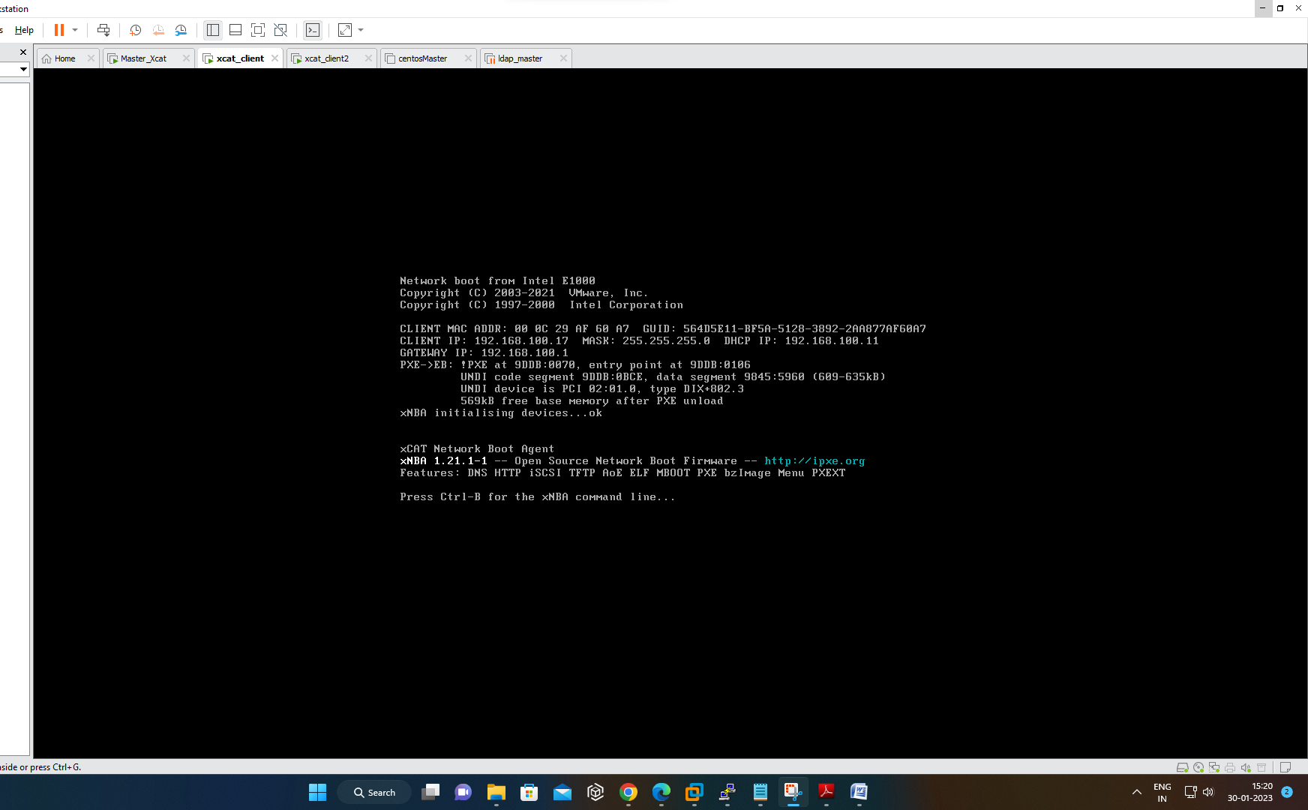

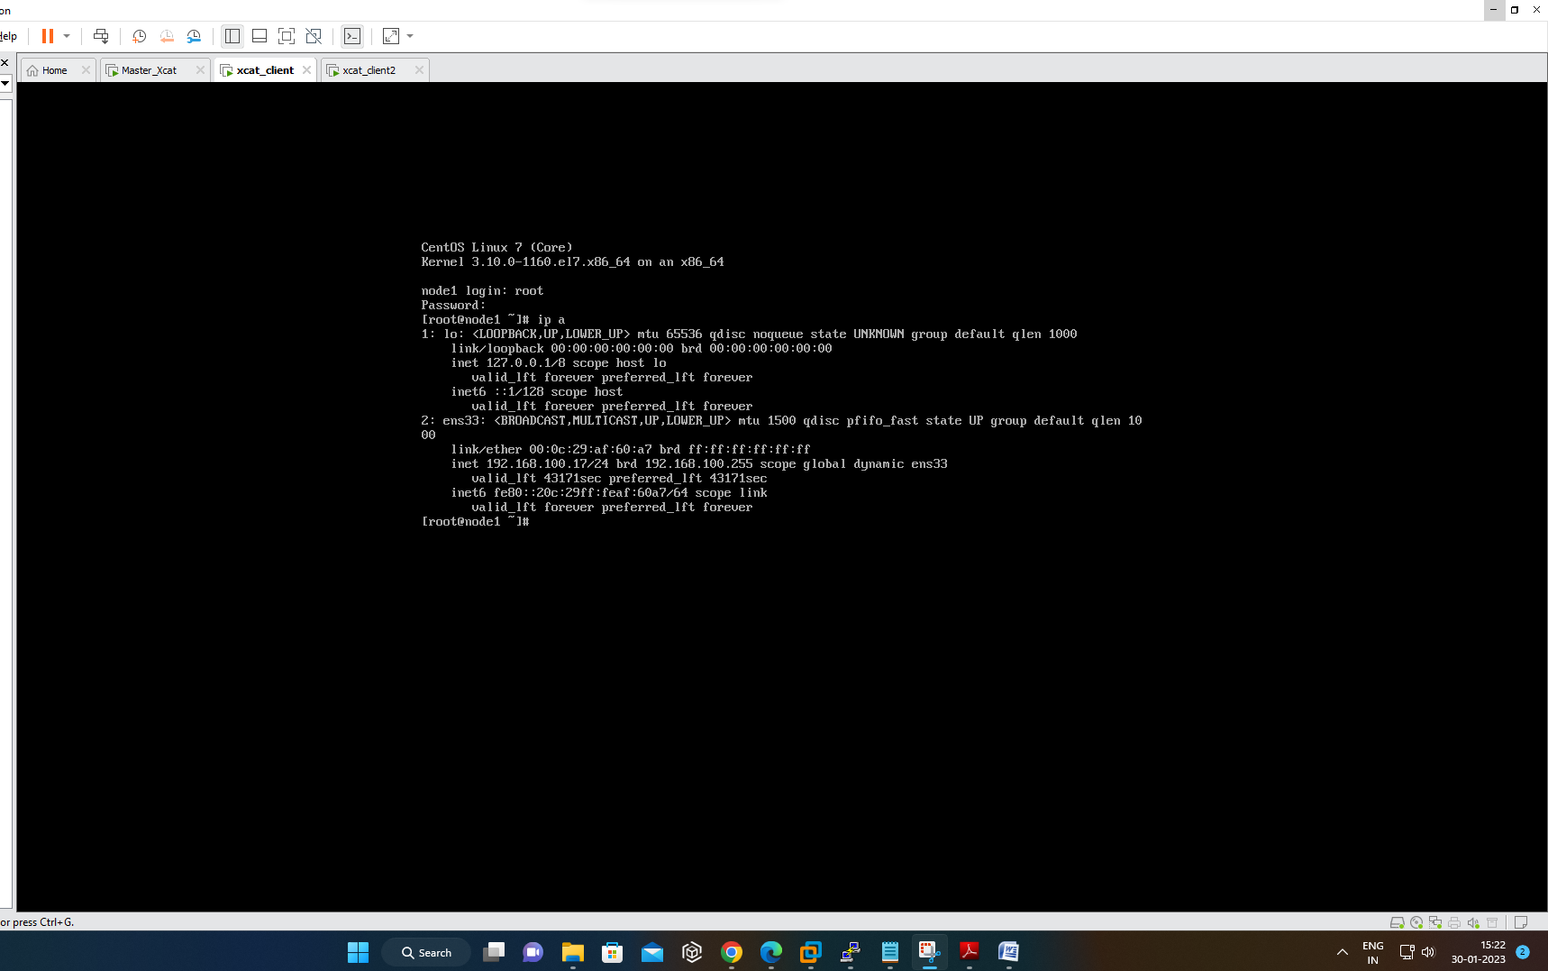

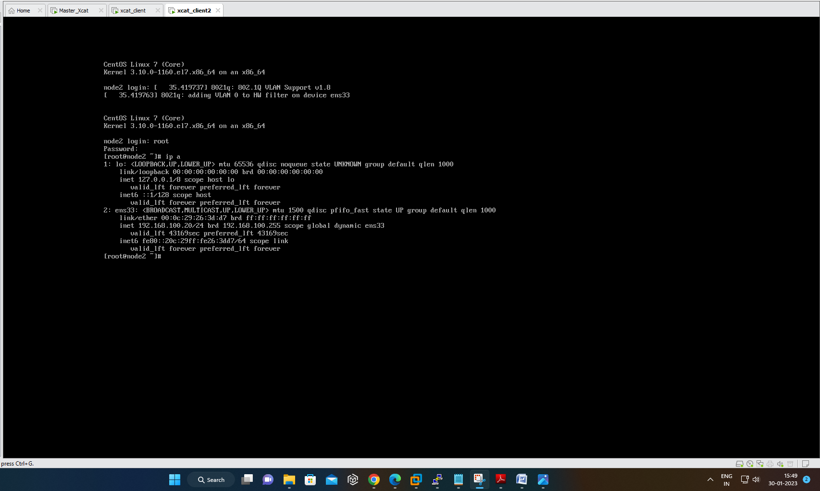

## LDAP Configuration

* **On Master Node:-**
* **Install OpenLDAP**

**#**yum -y install openldap-servers openldap-clients

#cp /usr/share/openldap-servers/DB_CONFIG.example /var/lib/ldap/DB_CONFIG

#chown ldap. /var/lib/ldap/DB_CONFIG

#systemctl start slapd

#systemctl enable slapd

# generate encrypted password

#save this password to a file

# password from user

#vi chrootpw.ldif

specify the password generated above for "olcRootPW" section

dn: olcDatabase={0}config,cn=config

changetype: modify

add: olcRootPW

olcRootPW: {SSHA}xxxxxxxxxxxxxxxxxxxxxxxx

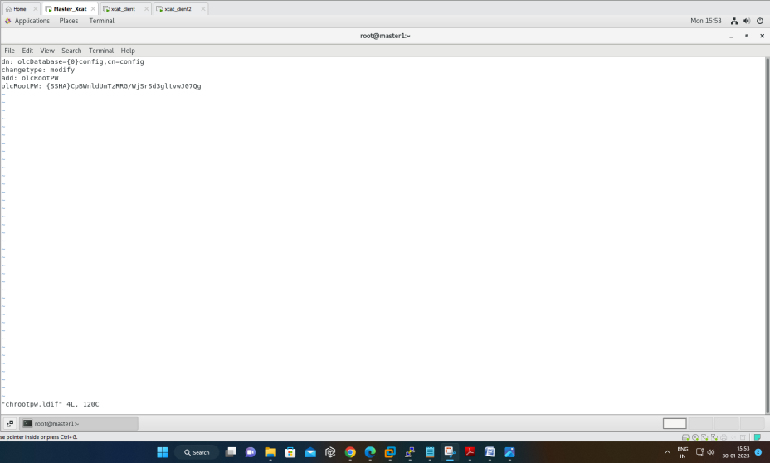

#ldapadd -Y EXTERNAL -H ldapi:/// -f chrootpw.ldif

#ldapadd -Y EXTERNAL -H ldapi:/// -f /etc/openldap/schema/cosine.ldif

#ldapadd -Y EXTERNAL -H ldapi:/// -f /etc/openldap/schema/nis.ldif

#ldapadd -Y EXTERNAL -H ldapi:/// -f /etc/openldap/schema/inetorgperson.ldif

* **generate directory manager's password**

#slappasswd

#vi chdomain.ldif

# replace to your own domain name for "dc=***,dc=***" section

# specify the password generated above for "olcRootPW" section

dn: olcDatabase={1}monitor,cn=config

changetype: modify

replace: olcAccess

olcAccess: {0}to * by dn.base="gidNumber=0+uidNumber=0,cn=peercred,cn=external,cn=auth"

read by dn.base="cn=Manager,dc=casestudy,dc=in" read by * none

dn: olcDatabase={2}hdb,cn=config

changetype: modify

replace: olcSuffix

olcSuffix: dc=casestudy,dc=in

dn: olcDatabase={2}hdb,cn=config

changetype: modify

replace: olcRootDN

olcRootDN: cn=Manager,dc=casestudy,dc=in

dn: olcDatabase={2}hdb,cn=config

changetype: modify

add: olcRootPW

olcRootPW: {SSHA}xxxxxxxxxxxxxxxxxxxxxxxx

dn: olcDatabase={2}hdb,cn=config

changetype: modify

add: olcAccess

olcAccess: {0}to attrs=userPassword,shadowLastChange by

dn="cn=Manager,dc=casestudy,dc=in" write by anonymous auth by self write by * none

olcAccess: {1}to dn.base="" by * read

olcAccess: {2}to * by dn="cn=Manager,dc=casestudy,dc=in" write by * read

#ldapmodify -Y EXTERNAL -H ldapi:/// -f chdomain.ldif

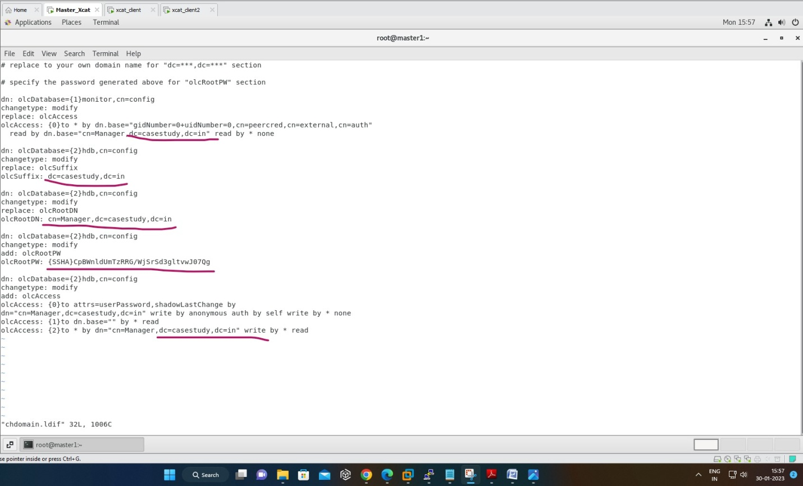

#vi basedomain.ldif

# replace to your own domain name for "dc=***,dc=***" section

dn: dc=casestudy,dc=in

objectClass: top

objectClass: dcObject

objectclass: organization

o: casestudy in

dc: Casestudy

dn: cn=Manager,dc=casestudy,dc=in

objectClass: organizationalRole

cn: Manager

description: Directory Manager

dn: ou=People,dc=casestudy,dc=in

objectClass: organizationalUnit

ou: People

dn: ou=Group,dc=casestudy,dc=in

objectClass: organizationalUnit

ou: Group

ldapadd -x -D cn=Manager,dc=casestudy,dc=in -W -f basedomain.ldif

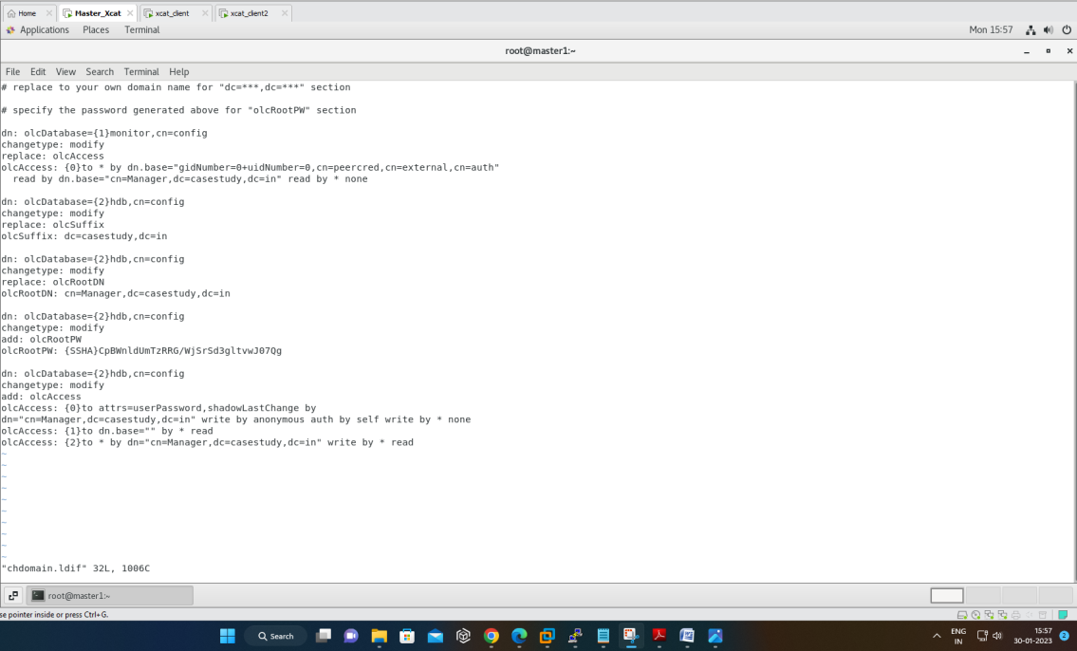

#vi ldapuser.ldif

# create new

# replace to your own domain name for "dc=***,dc=***" section

dn: uid=hpcsa2,ou=People,dc=casestudy,dc=in

objectClass: inetOrgPerson

objectClass: posixAccount

objectClass: shadowAccount

cn: hpcsa2

sn: Linux

userPassword: {SSHA}xxxxxxxxxxxxxxxxx

loginShell: /bin/bash

uidNumber: 1003

gidNumber: 1003

homeDirectory: /home/hpcsa2

dn: cn=hpcsa2,ou=Group,dc=casestudy,dc=in

objectClass: posixGroup

cn: hpcsa2

gidNumber: 1003

memberUid: hpcsa2

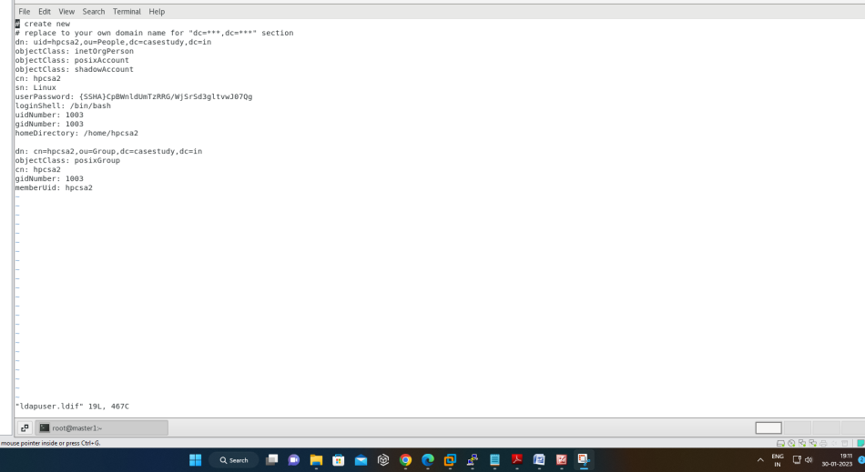

#ldapadd -x -D cn=Manager,dc=casestudy,dc=in -W -f ldapuser.ldif

#systemctl start slapd

#systemctl status slapd

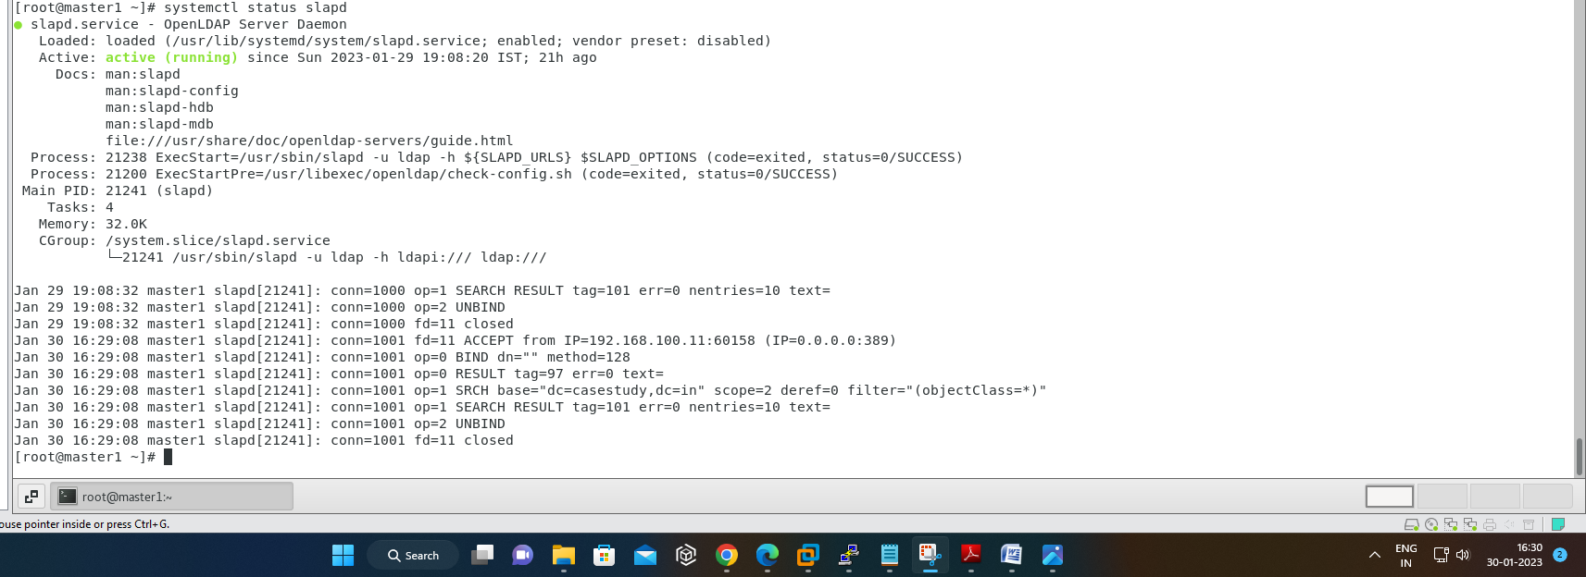

* **On clientNodes**

**Install OpenLDAP Client.**

#yum --installroot=/install/netboot/hpcsa2os7.9/x86_64/compute/rootimg install openldap-clients

#exports CHROOT=/install/netboot/hpcsa2os7.9/x86_64/compute/rootimg

#chroot $CHROOT

#authconfig --enableldap --enableldapauth --ldapserver=master --ldapbasedn="dc=casestudy,dc=in" --enablemkhomedir --update

#systemctl restart nslcd

#systemctl enable nslcd

#systemctl status nslcd

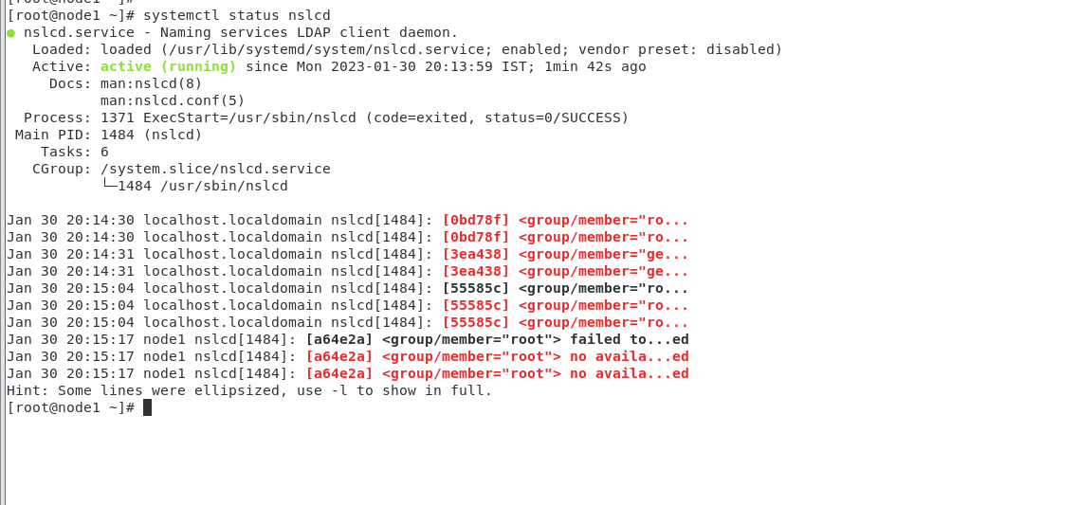

#ldapsearch –x



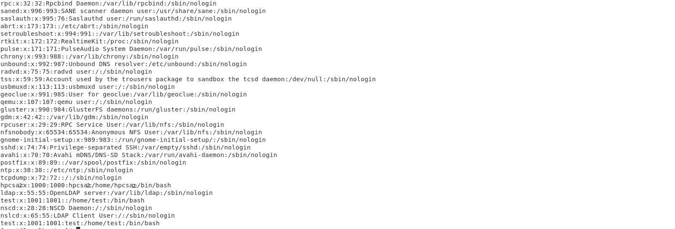

# Slurm Configuration

* **On Master Node**

#wget https://download.schedmd.com/slurm/slurm-22.05.7.tar.bz2

#rpmbuild slurm-22.0507.tar.bz2

#yum install -y mariadb-server mariadb-devel epel-release munge munge-libs munge-devel rpm-build python3 perl-ExtUtitils-Install gcc

#yum install openssl openssl-devel pam-devel numactl numactl-devel hwloc hwloc-devel lua lua-devel readline-devel rrdtool-devel ncurses-devel man2html libibmad libibumad -y

#/usr/sbin/create-munge-key -r

#chown munge:munge /etc/munge

#chmod 400 /etc/munge/munge.key

#cd /root/rpmbuild/RPMS/x86_64/

#yum install slurm*

#export SLURMUSER=900

#groupadd -g $SLURMUSER slurm

#useradd -m -c "SLURM workload manager" -d /var/lib/slurm -u $SLURMUSER -g slurm -s /bin/bash slurm

#cp /etc/slurm/slurm.conf.example /etc/slurm/slurm.conf

#vi /etc/slurm/slurm.conf

clusturname=oxygen

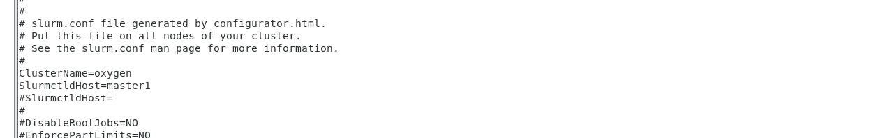

#mkdir -p /var/share/slurm/ctld

#vi /etc/slurm/slurm.conf

stateSaveLocation=/var/share/slurm/ctld

SlurmSpoolDir=/var/share/slurm/d

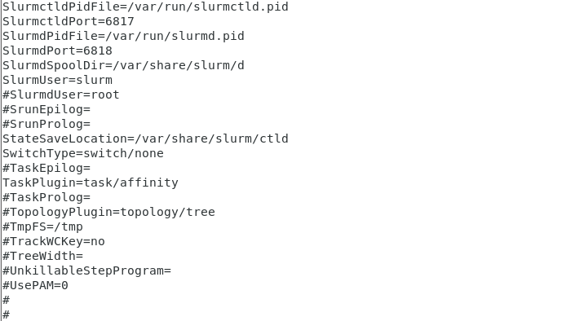

#chown -R slurm:slurm /var/share/slurm

#touch /var/log/slurmctld.log

#systemctl start slurmctld

#systemctl status slurmctld

#systemctl enable slurmctld

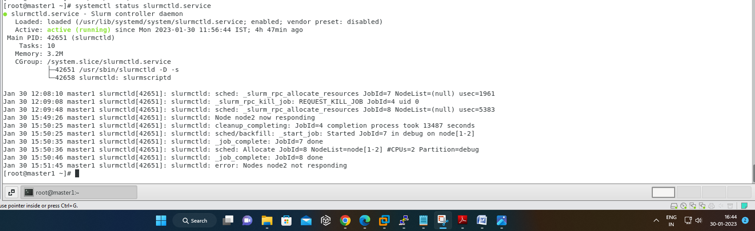

#systemctl status munge

#systemctl start munge

#systemctl enable munge

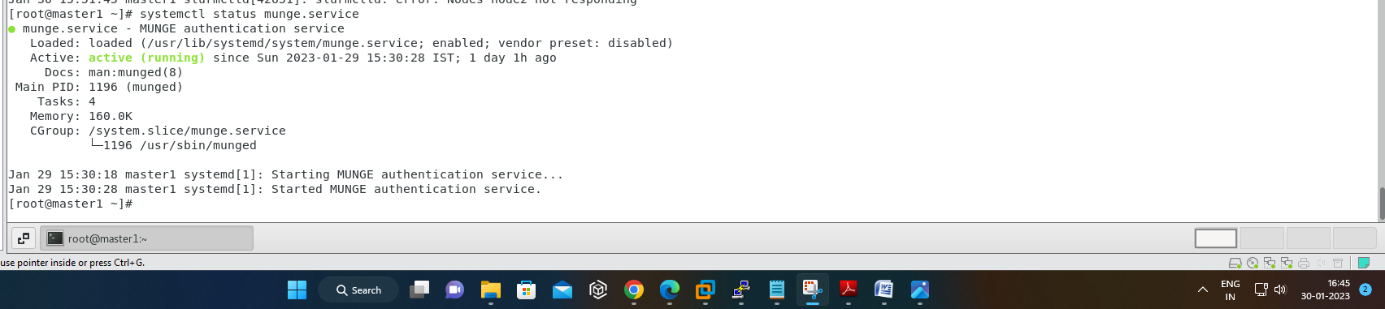

* **On Client:-**

#yum --installroot=$CHROOT install -y mariadb-server mariadb-devel epel-release munge munge-libs munge-devel rpm-build python3 perl-ExtUtitils-Install gcc

#scp /etc/munge/munge.key /install/netboot/hpcsa2os7.9/x86_64/compute/rootimg/etc/munge

#yum --installroot=$CHROOT install -y openssl openssl-devel pam-devel numactl numactl-devel hwloc hwloc-devel lua lua-devel readline-devel rrdtool-devel ncurses-devel man2html libibmad libibumad –y

#cd /etc/munge/

#chown munge:munge munge.key

#cd /root/rpmbuild/RPMS/x86_64/

# yum --installroot=$CHROOT install slurm*

#scp /etc/slurm/cgroup.conf $CHROOT/etc/slurm

#sinfo

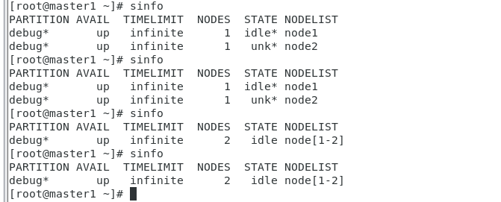

#srun –N2 –pty /bin/bash



#squeue



# Ganglia Configuration

* **On Master Node:**

#yum install epel-release

# yum install ganglia rrdtool ganglia-gmetad ganglia-gmond ganglia-web

#htpasswd -c /etc/httpd/auth.basic adminganglia

# vi /etc/httpd/conf.d/ganglia.conf

#vi /etc/ganglia/gmetad.conf

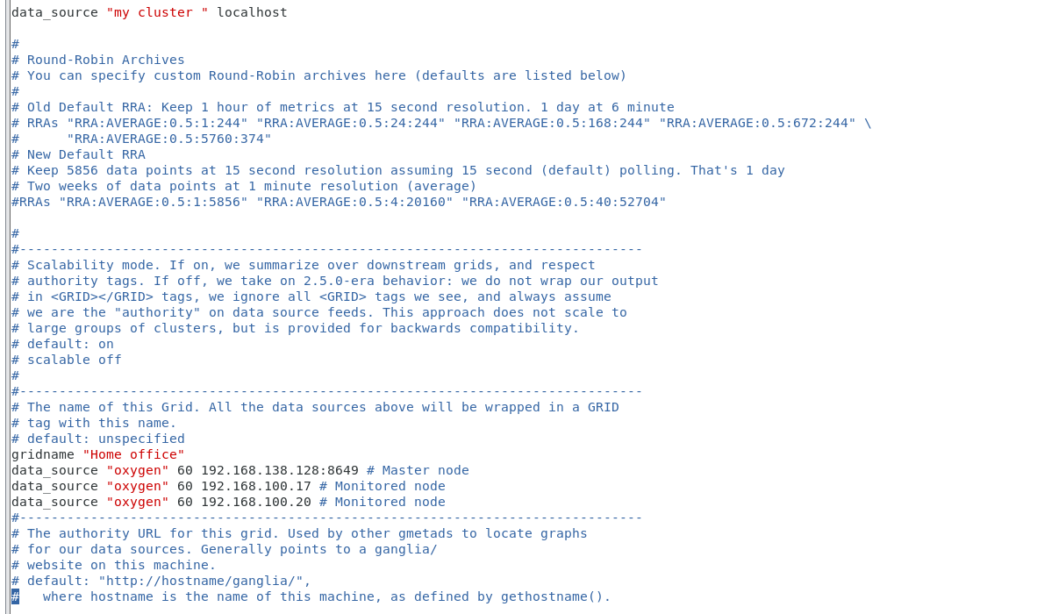

#vi /etc/ganglia/gmond.conf

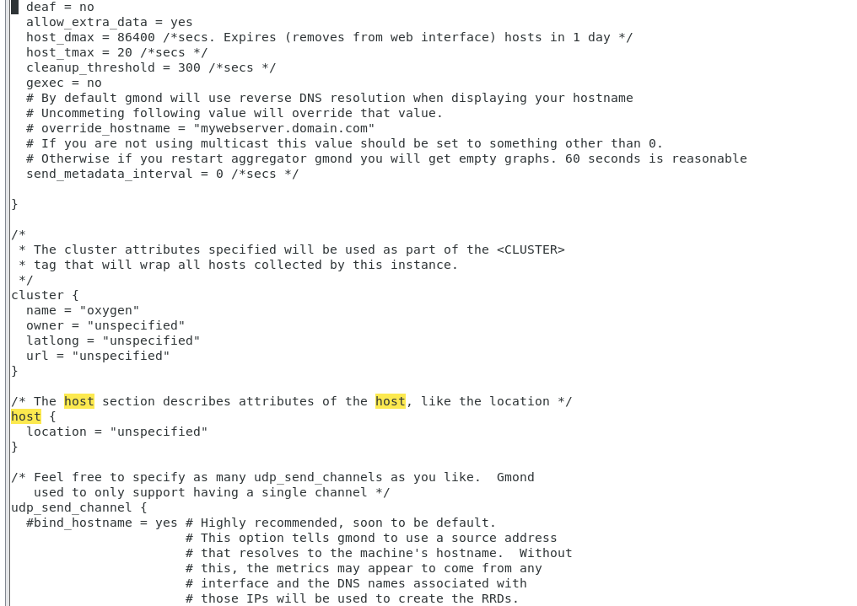

#setsebool -P httpd_can_network_connect 3

#systemctl restart httpd gmetad gmond

#systemctl enable httpd gmetad httpd

#systemctl status httpd gmetad httpd

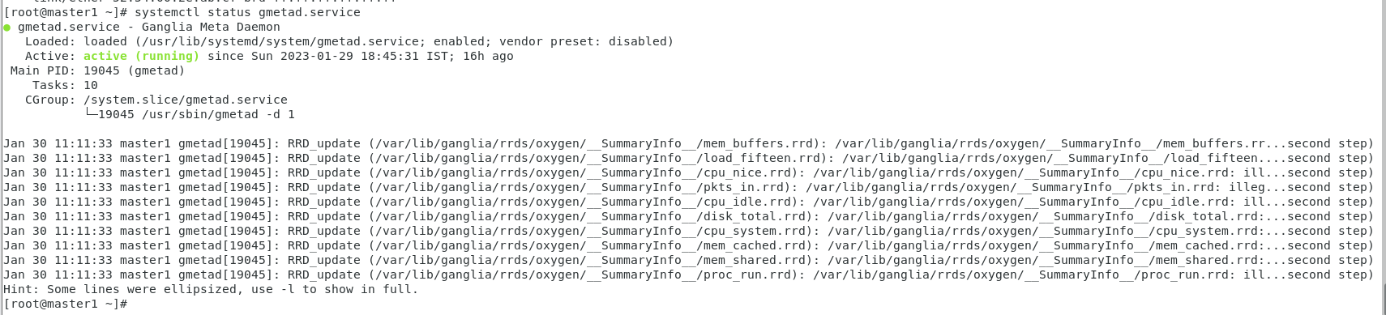

* **On Client Node:**

#export CHROOT=/install/netboot/hpcsa2os7.9/x86_64/compute/rootimg

#yum --installroot=$CHROOT install ganglia rrdtool ganglia-gmetad ganglia-gmond ganglia- web

#vi /etc/ganglia/gmond.conf

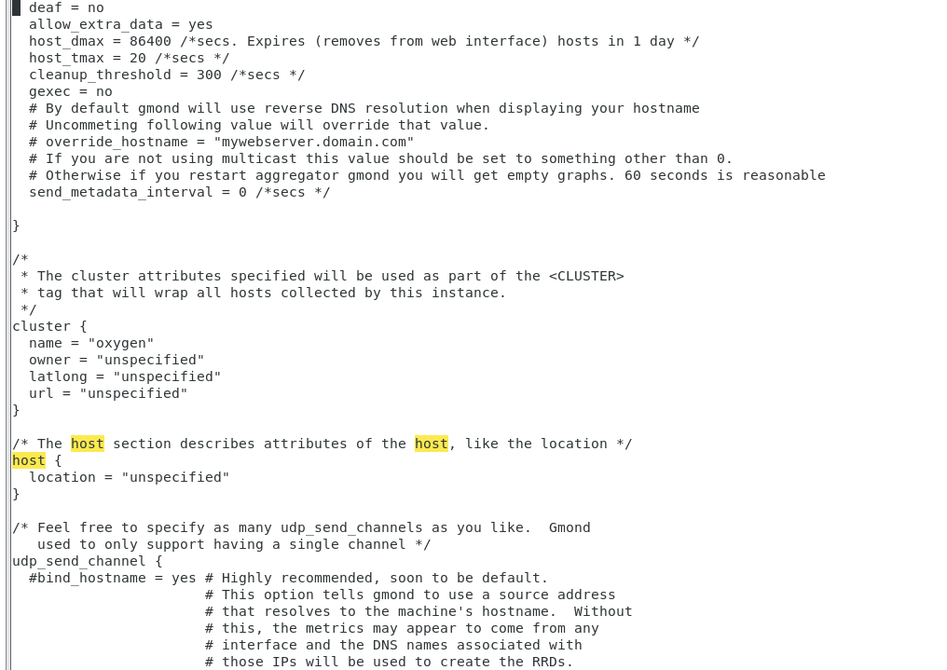

# packimage hpcsa2os7.9-x86_64-netboot-compute

#systemctl status gmond

* **On Client node1 & node2:-**

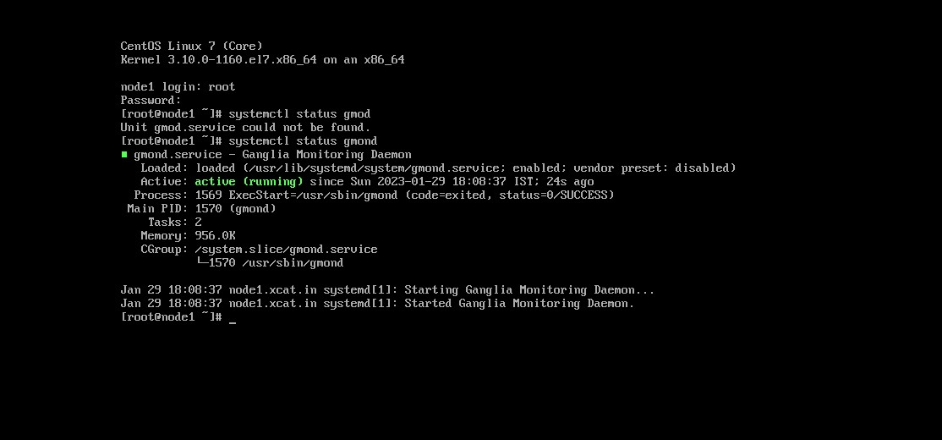

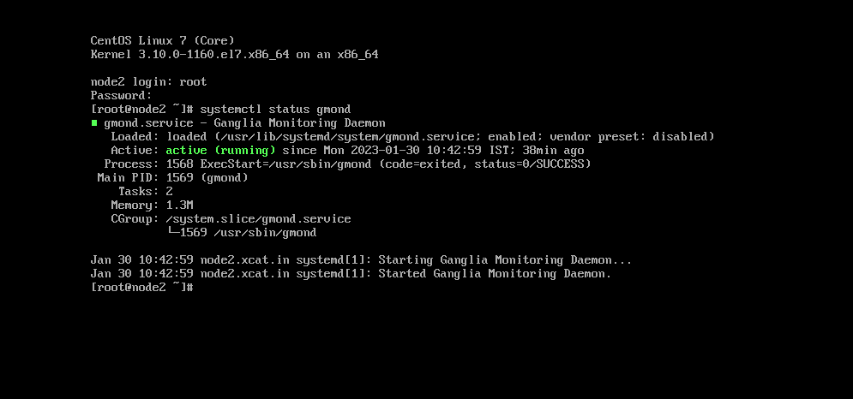

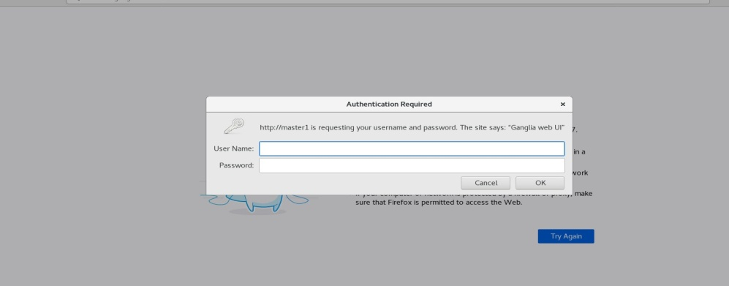

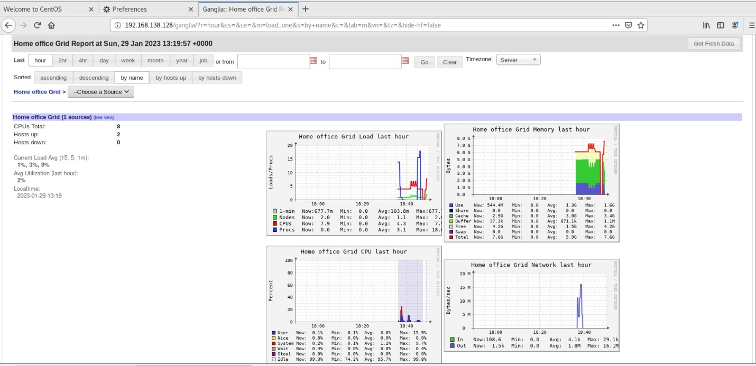

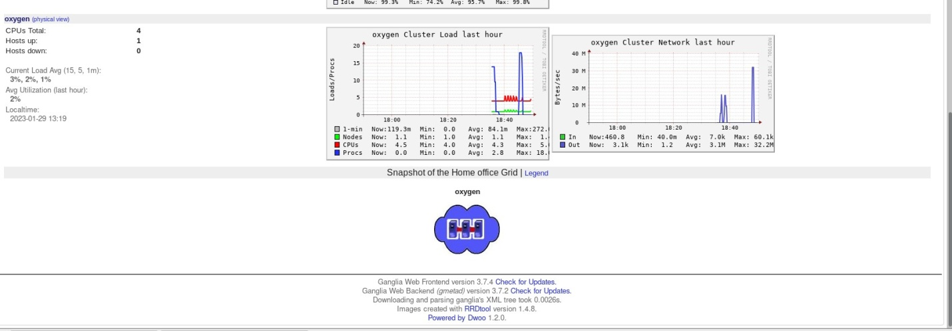



# Benchmarking

#yum install blas

# yum install epel-release

# yum install atlas

# yum install blas-devel

# wget https://netlib.org/benchmark/hpl/hpl-2.3.tar.gz

# tar -xvf hpl-2.3.tar.gz

# wget https://download.open-mpi.org/release/open-mpi/v4.1/openmpi-4.1.4.tar.gz

# tar -xvf openmpi-4.1.4.tar.gz

# cd openmpi-4.1.4

#./configure --prefix=/opt/openmpi-4.1.4 --enable-orterun-prefix-by-default

# make –j4

# make install

# export PATH=/opt/openmpi-4.1.4/bin:$PATH

# echo$PATH

# export LD_LIBRARY_PATH=/opt/openmpi-4.1.4/lib:$LD_LIBRARY_PATH

# cd /root/hpl-2.3/

# cd setup/

# cp Make.Linux_PII_CBLAS /root/hpl-2.3

#cd /root/hpl-2.3/

#vi Make.Linux_PII_CBLAS



#make arch=Linux_PII_CBLAS

#cd bin/

#cd Linux_PII_CBLAS/

#vim HPL.dat

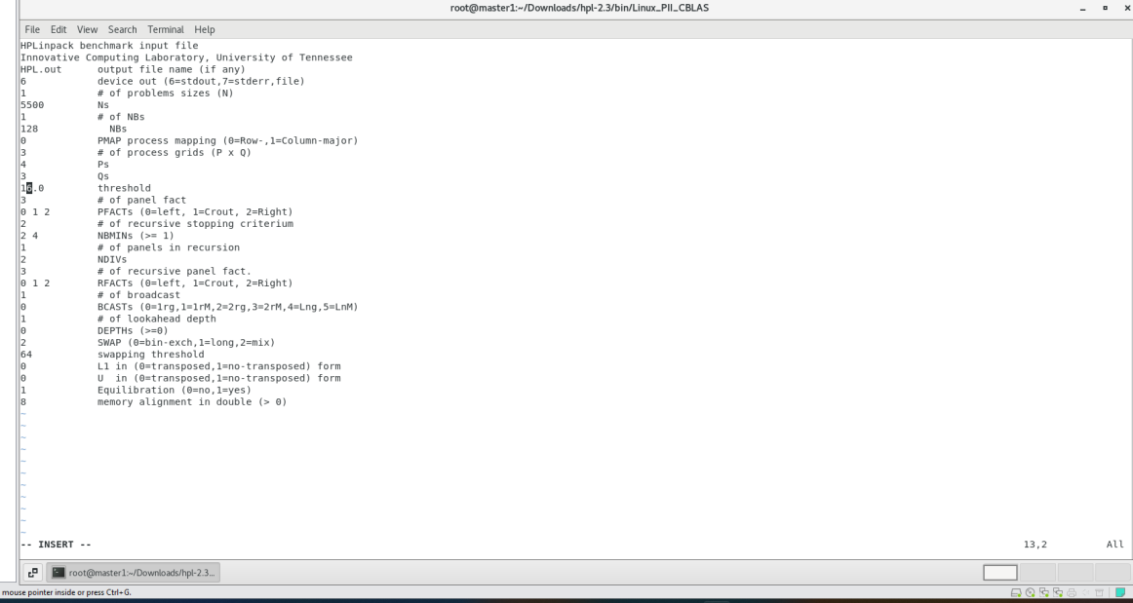

#mpirun --allow-run-as-root -np 12 ./xhpl HPL.dat

#mpirun --allow-run-as-root -np 12 --host master, node1,node2 ./xhpl HPL.dat



